**Issue 5**: Country field is missing

**Description**: The field to enter the country is missing in the address form

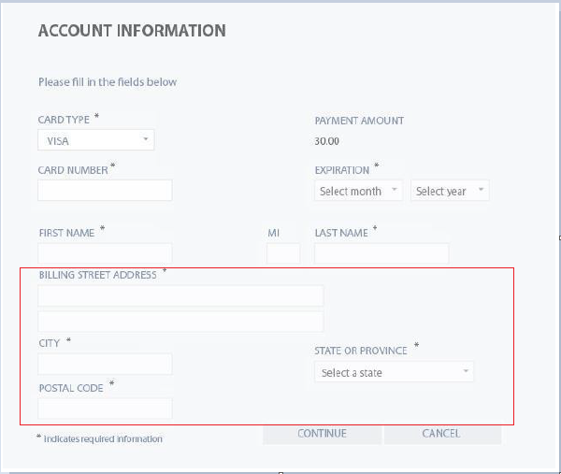

**Expected Behavior**: The address form should contain a field to enter the country

**Severity**: Major